Structure of the Transmembrane – Juxtamembrane Sequence of EGFR and its Interaction with Ca²⁺/Calmodulin

Taro Handai¹, Saburo Handai¹, and Hanako Handai^{1,2}

¹Institute for Protein Research, Osaka University, 3-2 Yamadaoka Suita, Osaka 565-0871, Japan, and ²Department of Biochmistry, Stony Brook University, NY 11794, USA
email: taro@osaka-u.ac.jp

summary summary summary summary summary summary summary summary summary summary summary summary summary summary summary summary summary summary summary summary summary summary summary summary summary summary summary summary summary summary summary summary summary summary summary summary summary summary summary summary summary summary summary summary summary summary summary summary

Keywords: membrane protein, nmr, thioester

Introduction
The epidermal growth factor receptor (EGFR) is a member of the ErbB receptor family and one of the first receptor tyrosine kinases (RTKs) to be characterized and linked to cancer. Crystal structures of the extracellular and the intracellular domains have been reported. The extracellular structure provides important information for understanding the activation mechanism. In contrast, the crystal structure of the intracellular domain has been puzzling. Unlike other RTKs, the activation loop within the kinase domain of the unphosphorylated receptor is in an active conformation, suggesting there are additional mechanisms for regulating kinase activity. Recently, we have proposed an electrostatic engine model (Fig.1) for the autoinhibition and activation of the EGFR/ErbB family that explains many of the experimental observations concerning receptor activity [1]. The model postulates that in the inactive receptor, the juxtamembrane and kinase domains associate

Table 1. Caption is Italic in 13pt font size
 | a | b | c | d
e | f | g | h | i
j | k | l | m | n
o | p | q | r | s
t | u | v | w | x
Notes are in 10pt font size
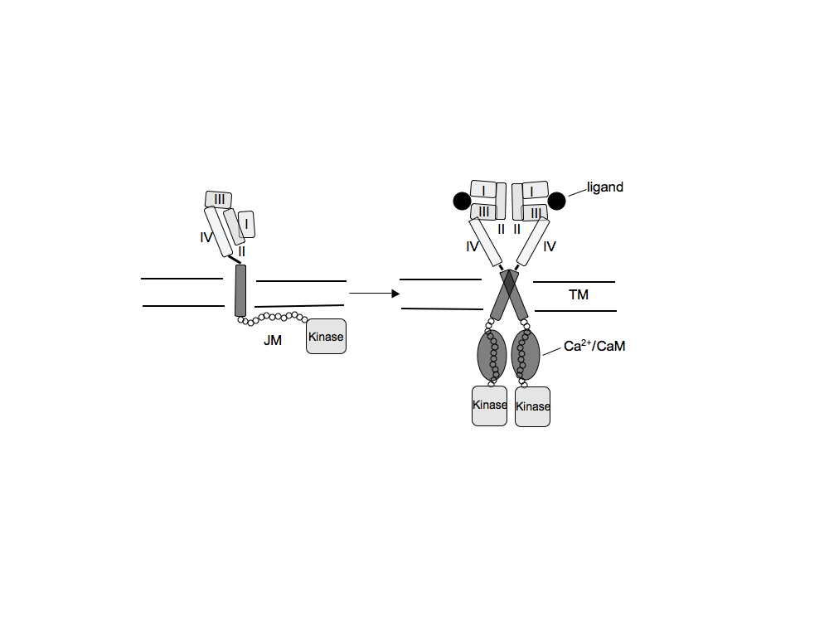

Fig.1 Electrostatic engine model

electrostatically with the negatively charged plasma membrane. The JM domain has a net (+8) positive charge, while electrostatic potential calculations reveal that one face of the kinase domain has a strong positive profile. The proposed mechanism of autoinhibition is by spatially separating the kinase domains in the EGFR dimer. Binding of the Ca²⁺ complex of calmodulin to the positively charged JM sequence releases the kinase domain from the membrane and leads to full activation of the receptor.
The studies described here extend our measurements on the 16-residue JM peptides to a sequence that includes the full membrane-spanning domain of EGFR reconstituted into bilayer vesicles for further understanding of the regulation for EGFR activity.

Results and Discussion
A key feature of the model proposed in Fig. 1 is a break in the transmembrane (TM) helix at the membrane boundary. In order to get an insight on the structure of the TM-JM sequence of the receptor, we obtained ¹³C spectra of the sequence, EGFR(622-660), containing specific backbone ¹³C labels at the putative TM-JM boundary. The TM-JM peptide was reconstituted into DMPC/DMPG multilamellar vesicles for these experiments. The carbonyl carbon ¹³C chemical shifts are sensitive to secondary structure [2]. The results showed that the TM helix breaks at the membrane interface.
Next, we address the questions: does the JM region bind to the membrane and is Ca²⁺/calmodulin able to pull the JM region from the membrane surface in the context of the full TM-JM sequence? In designing the experiment, we took an advantage of the previous finding that the JM portion of EGFR sequesters PIP₂ [1]. Binding of the JM sequence to the membrane was measured using fluorescence resonance energy transfer (FRET) between a fluorescent Bodipy-TMR label on PIP₂ and a Texas-Red label attached to a C-terminal cysteine of the TM-JM peptide, EGFR(622–660). The results showed that the JM region associates with the membrane surface with the ability to sequester PIP₂ and Ca²⁺/calmodulin can pull the JM region from the membrane surface.
The results shown here support models that suggest the cytoplasmic juxtamembrane region of EGFR plays an active role in regulating receptor activity.

References
- McLaughlin, S., Smith, S. O., Hayman, M. J., and Murray, D. (2005) J. Gen. Physiol., 126, 41-53.
- Saito, H., Tuzi, S., and Naito, A. (1998) Annu. Rep. NMR Spectrosc., 36, 79-121.

