Design and Synthesis of Hypoxia-responsive Amino Acid Which Causes Peptide Bond Cleavage in Hypoxic Cells

Akira Shigenaga, Keiji Ogura, Hiroko Hirakawa, Jun Yamamoto, Koji Ebisuno, Licht Miyamoto, Keisuke Ishizawa, Koichiro Tsuchiya, and Akira Otaka

Institute of Health Biosciences and Graduate School of Pharmaceutical Sciences,
The University of Tokushima, Shomachi, Tokushima 770-8505, Japan.
shigenaga.akira@tokushima-u.ac.jp

A hypoxia-responsive amino acid which causes peptide bond cleavage in hypoxic cells is highly demanded for development of hypoxic tumor-specific peptide-based prodrugs. Hypoxia-responsive removal of nitroarylmethyl groups is the most attractive triggering reactions for the hypoxia-responsive prodrugs. In this paper, design and synthesis of the hypoxia-responsive amino acid possessing a 4-nitrobenzyl group is described. Its application to the hypoxia-responsive peptide bond cleavage is also reported.

Keywords: hypoxia-responsive, peptide bond cleavage, prodrug, stimulus-responsive, trimethyl lock

Introduction
Bioreduction followed by removal of nitroarylmethy groups is among the most attractive triggering reactions of hypoxic-tumor specific antitumor prodrugs [1]. To prepare peptide-based prodrugs for hypoxic tumors, a hypoxia-responsive unit that induces functional change in hypoxic cells is indispensable. Previously, we reported a stimulus-responsive amino acid that induces peptide bond cleavage after a stimulus-triggered removal of a protective group (PG) followed by lactonization of a trimethyl lock moiety (Fig. 1) [2], and its application to control peptidyl functions in living cells. In this paper, development of a hypoxia-responsive amino acid that induces peptide bond cleavage in hypoxic cells is described.

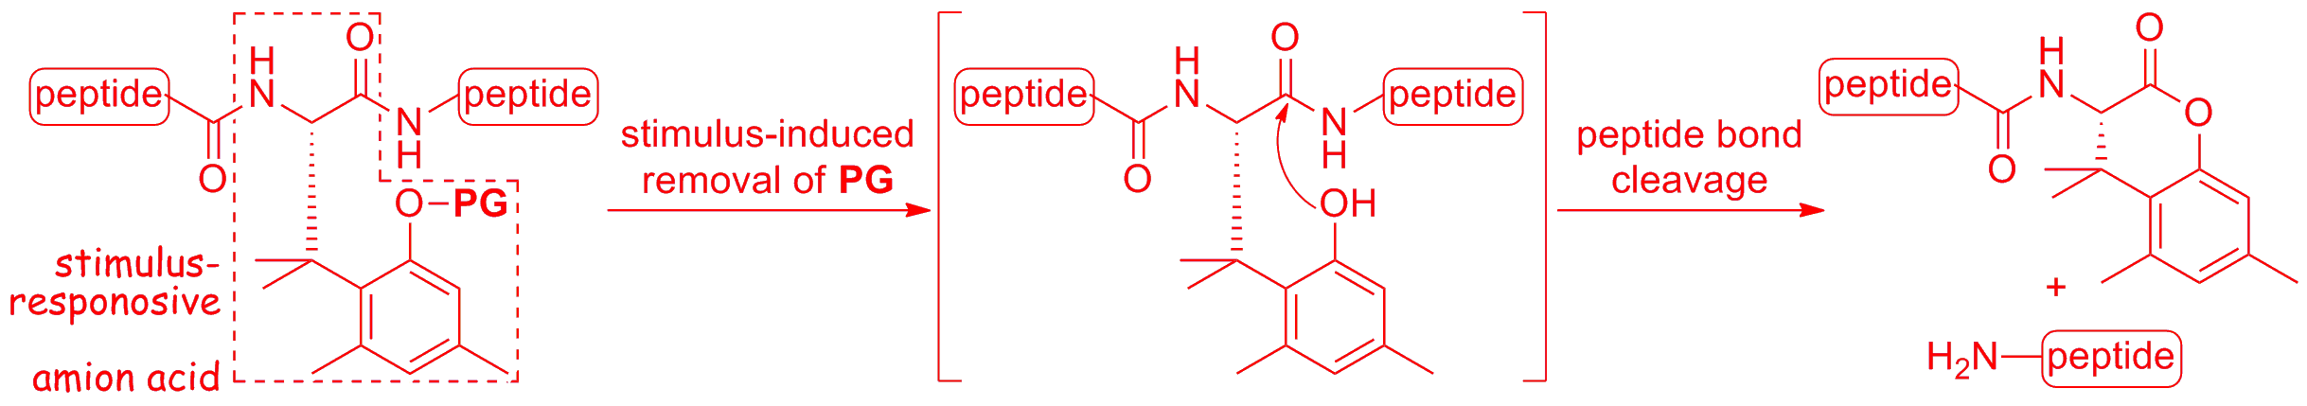
Fig.1. Stimulus-responsive amino acid (PG: a protective group removable by a stimulus).
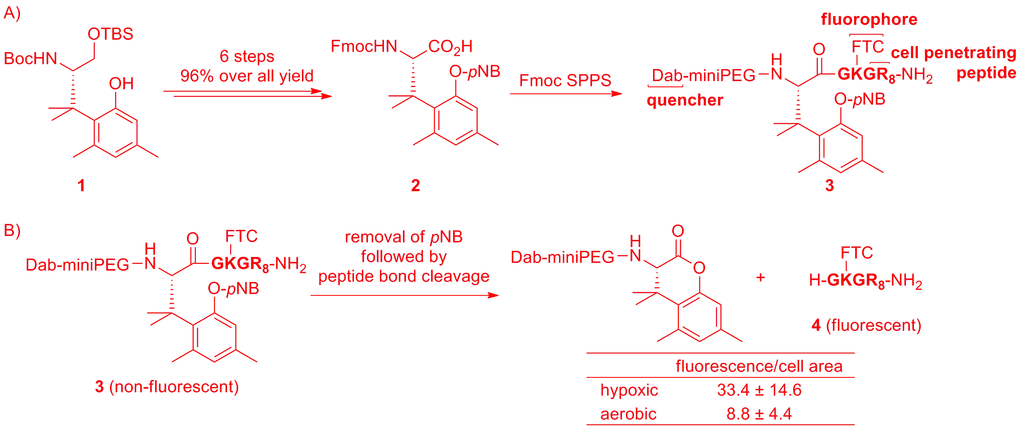
Fig.2. A) Synthesis of hypoxia-responsive amino acid. (pNB: p-nitrobenzyl; Dab: dabsyl; FTC: fluoresceinylamino thiocarbonyl). B) Cell-based assay of hypoxia-responsive peptide bond cleavage. Caco-2 cells were incubated with 300 nM 3 for 15 h under hypoxic (1% O₂ and 5% CO₂ in N₂) or aerobic (5% CO₂ in air) conditions. Fluorescent per cell area is the average of 4 runs (10 cells per a run).

Results and Discussion
In this study, a p-nitrobenzyl (pNB) group was introduced as the PG because it can easily be removed under hypoxic conditions [3] (Fig. 2A). Fmoc-protected hypoxia-responsive amino acid 2 was synthesized starting from phenol 1 in a manner similar to that of a UV-responsive amino acid [4]. Then, FRET substrate 3 was prepared to demonstrate its ability to induce peptide bond cleavage in hypoxic cells. Peptide 3 possesses a fluorophore, a quencher, and a cell penetrating peptide sequence [5]. When it is added to a cell, peptide 3 will internalize into the cell but not show fluorescence because of quenching by FRET. If a peptide bond of 3 is cleaved, fluorescence of fragment 4 should be observed. Peptide 3 was incubated with Caco-2 cells for 15 h under hypoxic or aerobic conditions (Fig. 2B). Fluorescence intensity per cell area was estimated based on fluorescence microphotography images. As shown in the figure, the fluorescence under the hypoxic conditions was stronger than that under the aerobic conditions. Therefore, it was demonstrated that hypoxia-responsive amino acid 2 can induce the peptide bond cleavage in the hypoxic cells.
In conclusion, the hypoxia-responsive amino acid was developed. Its application to a hypoxia-responsive peptide-based prodrug is in progress.
This research was supported in part by a Grant-in-Aid for Scientific Research (KAKENHI). The Takeda Science Foundation is also acknowledged. J.Y. is grateful for a JSPS fellowship.

References
1. Chen, Y., Hu, L. (2009) Med. Res. Rev., 29, 29-64.
2. Shigenaga, A. (2012) J. Pharm. Soc. Jpn., 132, 1075-1082.
3. Nakata, E., Yukimachi, Y., Kariyazono, H., Im, S., Abe, C., Uto, Y., Maezawa, H., Hashimoto, T., Okamoto, Y., Hori, H. (2009) Bioorg. Med. Chem., 17, 6952-6958.
4. Shigenaga, A., Yamamoto, J., Nishioka, N., Otaka, A. (2010) Tetrahedron, 66, 7367-7372.
5. Nakase, I., Takeuchi, T., Tanaka, G., Futaki, S. (2008) Adv. Drug Delivery Rev., 60, 598-607.

